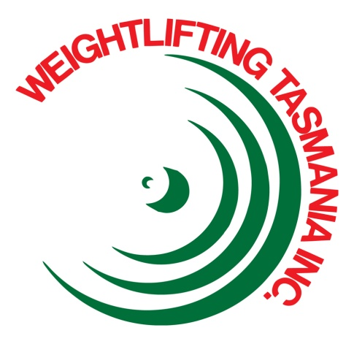
WEIGHTLIFTING TASMANIA INC.

Weightlifting Suit Policies

Objectives
- The objectives of the Weightlifting Suit policies are to:

- Ensure all competitors are wearing the appropriate apparel during competitions,
- Ensure that all state suits are of the appropriate standard.

Procedure

- State Championships

- Weightlifting suits are mandatory for all state championship events except under extenuating circumstances,
- The decision on if an athlete may lift without a lifting suit shall be made by the competition director,
- All weightlifting suits must be IWF standard,
- Skin-tight full body suits are allowed,
- Shirts may be worn underneath a weightlifting suit as long as the shirt does not cover the lifter’s elbows,

- Club Competitions

- The decision on whether lifting suits are mandatory during a competition shall be made by the Competition Director of that competition,
- WTI’s stance is that lifting suits shall not be mandatory,
- All weightlifting suits must be IWF standard,
- Skin-tight full body suits are allowed,
- Shirts may be worn underneath a weightlifting suit as long as the shirt does not cover the lifter’s elbows,
- Any competitions in which lifting suits are not mandatory in shall have the following apparel requirements:
- Tight fitting shorts or skins, and shirt that don’t cover the elbows or knees,
- Enclosed shoes.

- State Team

- All athletes selected for a state team must lift in a state suit,
- Athletes may borrow suits, they are not required to own one,
- Any variation of the state suit is permitted.
- State Suit

- State suits are any weightlifting suit that is currently, or has previously been, approved by the WTI Board as long as they conform to the rest of the WTI, AWF, and WTI policies and rules (If unsure, please contact the WTI board),
- State suits are required to have some or all of the following colours in their design:
- Bottle Green
- Maroon
- Yellow
- State suits must have the WTI logo, or other WTI insignia on the suit.

