Contact: Leo Isaac  Weightlifting Tasmania  Mobile: 0423 767 955  teacher@leoisaac.com | 14 Clear View Road  Crabtree, Tas 7109 | Weightlifting Tasmania

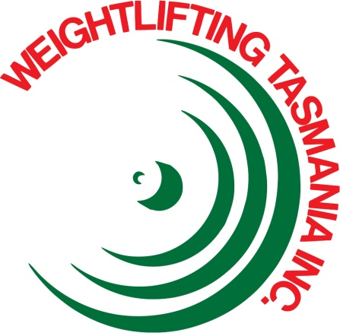

Press Release

Tasmanian Weightlifter in PNG

2015 Pacific Games, Port Moresby, Papua New Guinea
Port Moresby, Papua New Guinea, July 7, 2015: Camilla FOGAGNOLO, 28, Hobart resident, will alight the Weightlifting competition platform at the 2015 Pacific Games to represent Australia in the Women’s 75kg category TODAY. The competition starts at 4:00pm and is televised on NITV.
This is a major event for Camilla as she works to strengthen her position in the Australian team in the lead up to the 2015 World Championships in Houston, USA, in November.
This will be the toughest assignment that Camilla has faced in her 14 year career. Competition in Weightlifting across the Pacific Region is now very strong and Camilla will face opposition from Mary OPELOGE (Samoa) and Apolonia VAIVAI (Fiji) both who have totals higher than Camilla.
Camilla’s training base is the Weightlifting Academy of Tasmania, Glenorchy.

